Slaley, Healey & Minsteracres Local History Group
27 January 2025 7.30pm
Slaley Commemoration Hall

THE ART AND CRAFT OF GUITAR BUILDING
A TALK BY STEFAN SOBELL
I have been building guitars in my Whitley Chapel workshop for more than 40 years. I will talk informally about the processes involved, how I became an instrument maker, some of the difficulties and setbacks I encountered, and some of my famous (and less famous) customers. I will show slides of instruments in various stages, and bring a completed guitar together with examples of work in progress to show and discuss. Stefan Sobell

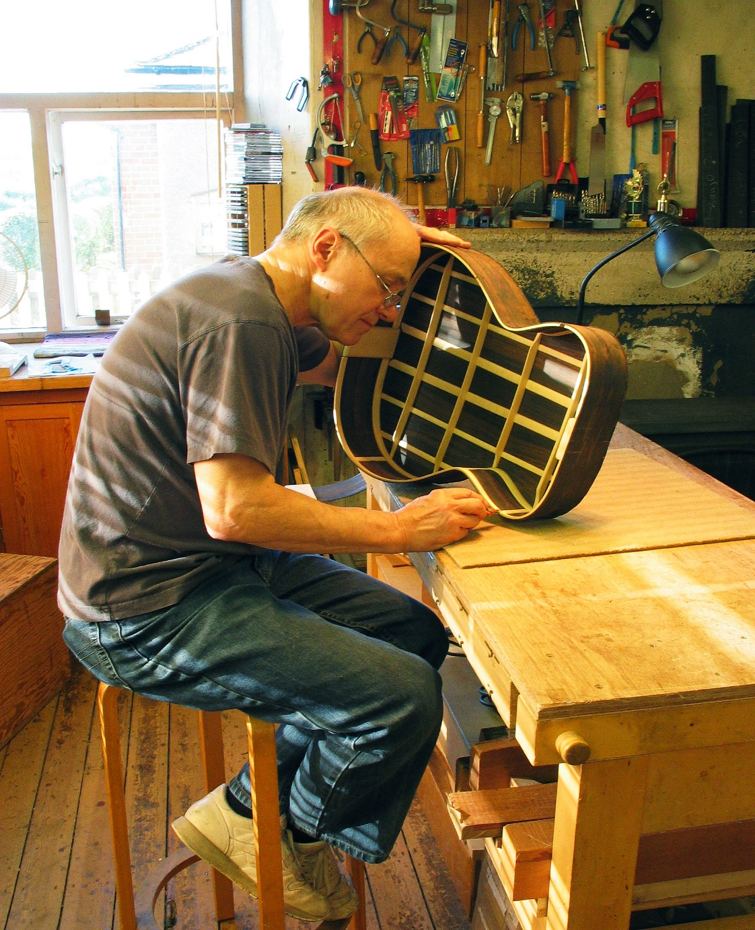

£4 adults or 50p for all in full-time education
For more information contact Pat Wilson 01434 673388 or email pat.wilson28@outlook .com

