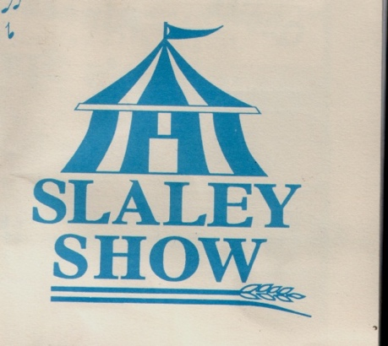
160th Slaley Show
10th August 2019

Membership Form.
1st January – 31st December 2019

Benefits include: membership badges which enable free entry to the Show, early Schedules, an email newsletter and the right to vote at the AGM.

Name/s ……………………………………………………………………………………………………………………………….

Address…………………………………………………………………………………………………………………………………

……………………………………………………………………………………………………………………………………………..

Email………………………………………………………………..email enables us to keep down costs and to send you a newsletter.

Membership (All groups) £10.00 Life Members ….Free. Under 12 years …..Free
£
Number of memberships required Total for membership.

£
Donations for Slaley Show are welcome. Thank you

Please treat my donation as a Gift Aid Donation. For this purpose, I confirm that I have paid or will pay an amount of Income Tax/ Capital Gains Tax that is at least equal to the amount that will be claimed on my donation which is 25p on every £1 of donation.

Signed …………………………………………………Date………………………………………………

Payment to Stella Douglas (Treasurer), Ardmore, Slaley, Hexham. NE47 0BY. Payment can be made electronically. Lloyds Bank. 30-94-19. Acc. 00140729. Please put initial and surname in the reference box so I can track membership. Please return this form either by post or by email.

Slaley Show Society Members and Stakeholders
The General Data Protection Regulation (GDPR).This is a law that gives everyone more control over their data and how it is used, and it is important that we ensure that your data is handled correctly. We have updated our privacy policy in line with the requirements set out by the General Data Protection Regulation. If you DO NOT wish to continue to communicate with the Slaley Show Society or if you want to see a copy of our policy please contact Stella Douglas (stellacdouglas@hotmail.com).

